**Online Exam System Project Screenshots**

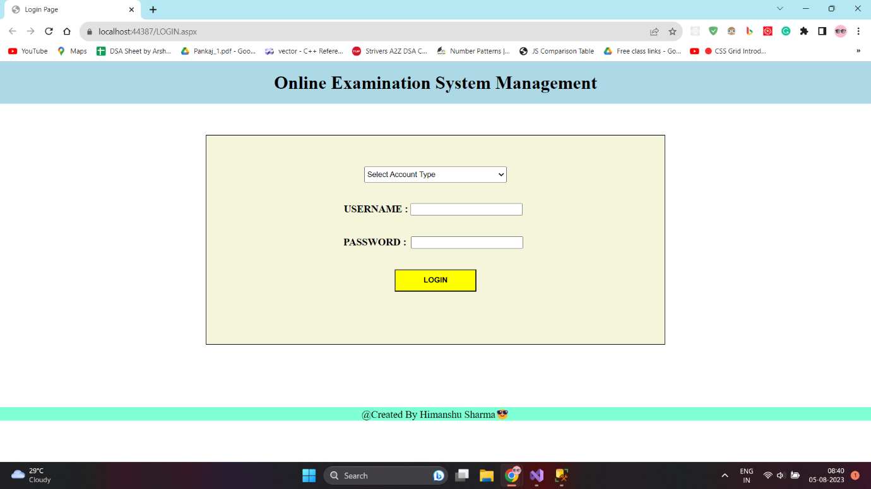

**Fig – Login Page for both Admin and Student**

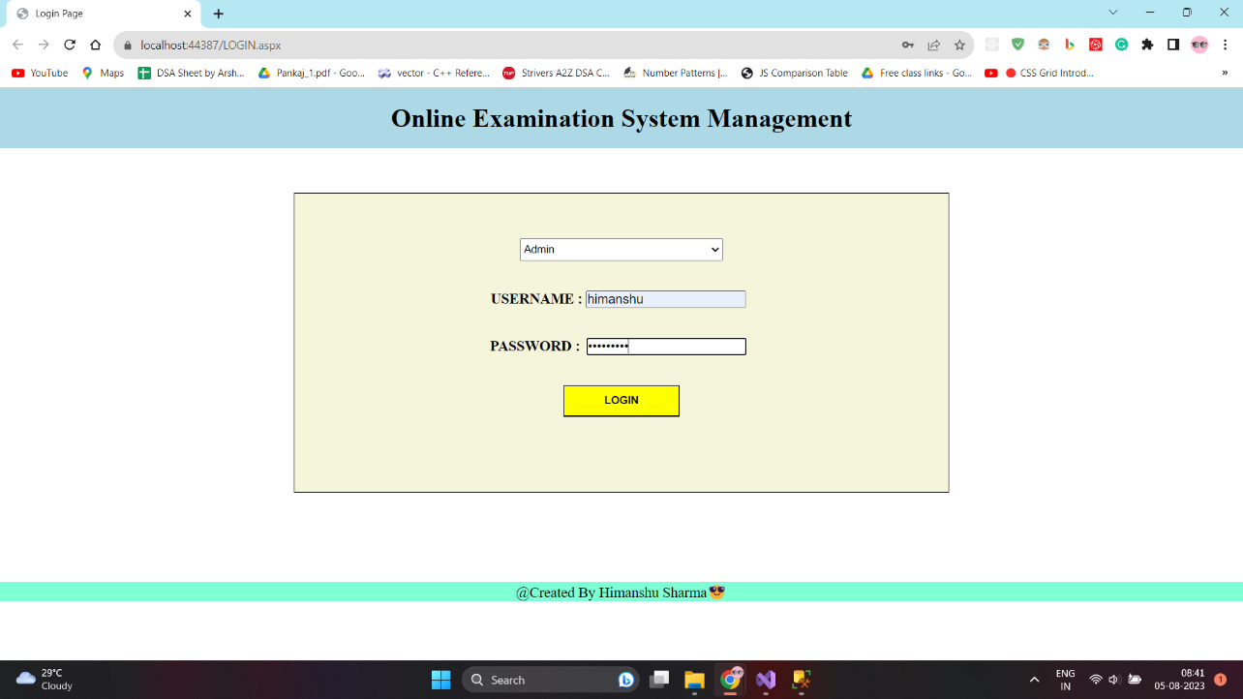

**Fig – entered admin details for login**

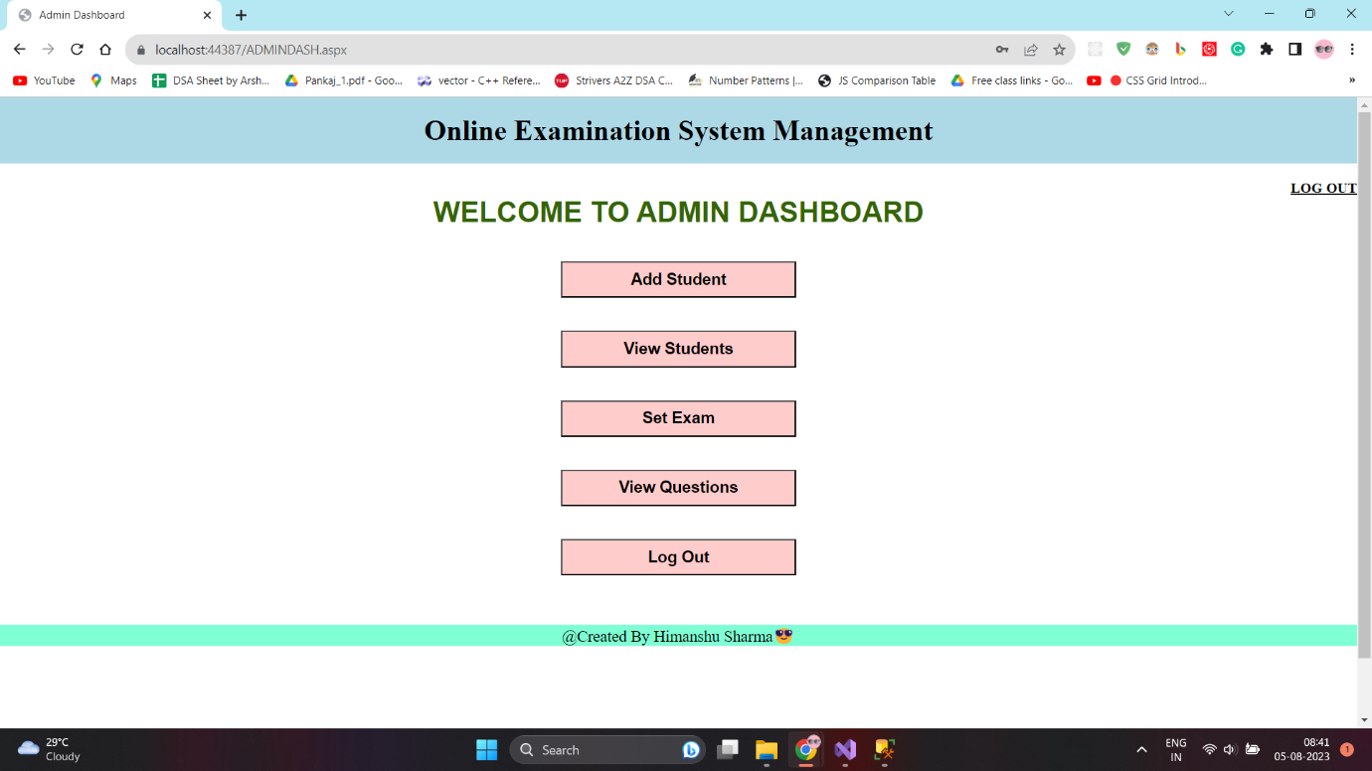

**Fig – Admin Dashboard Page**

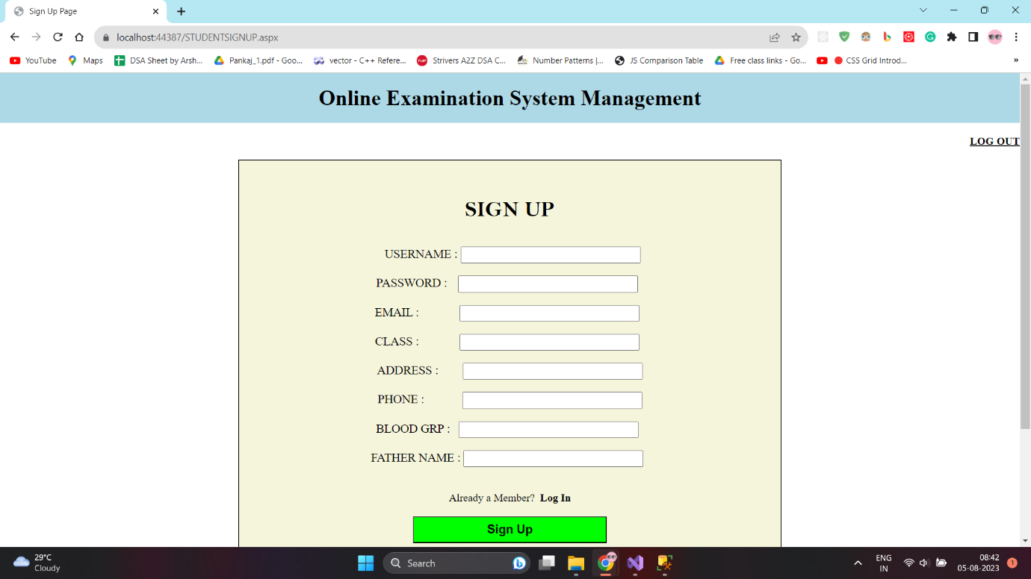

**Fig – Student signup page which is under Admin**

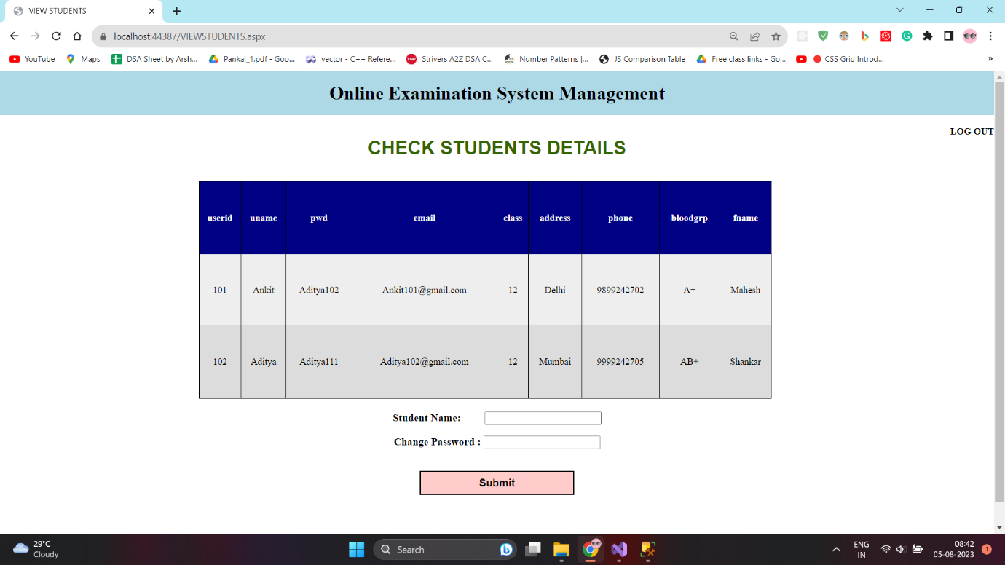

**Fig – View Student Details Page**

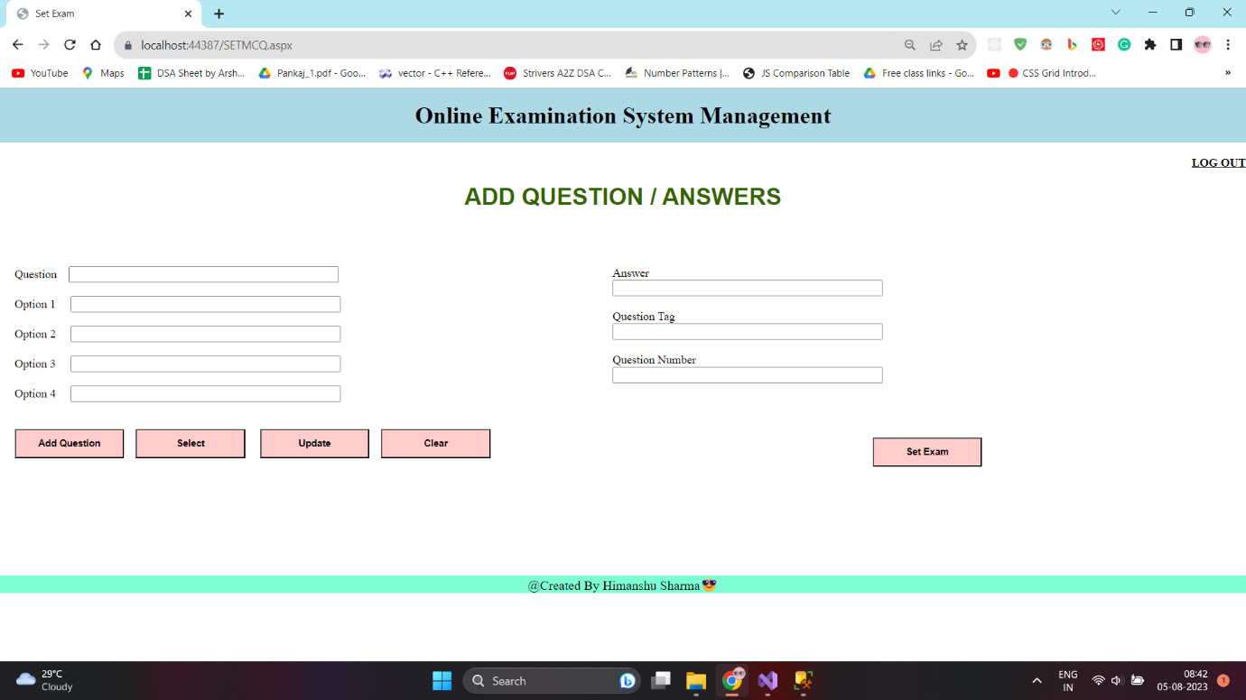

**Fig – Add Question/Answers Page in Admin Dash**

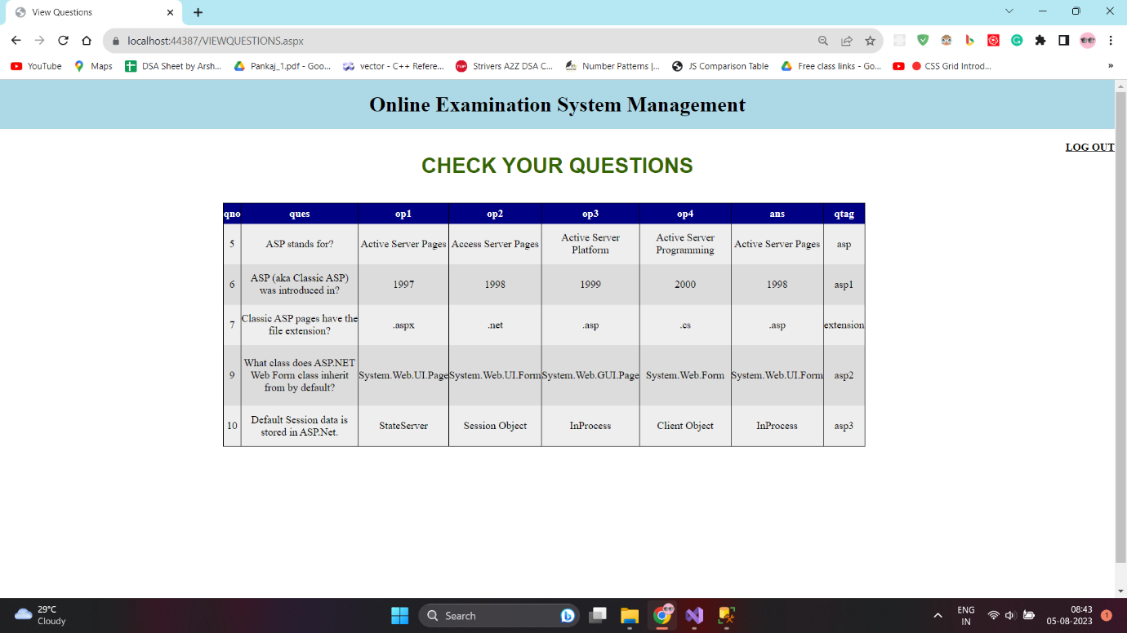

**Fig – view List Of Question Page in Admin Dashboard**

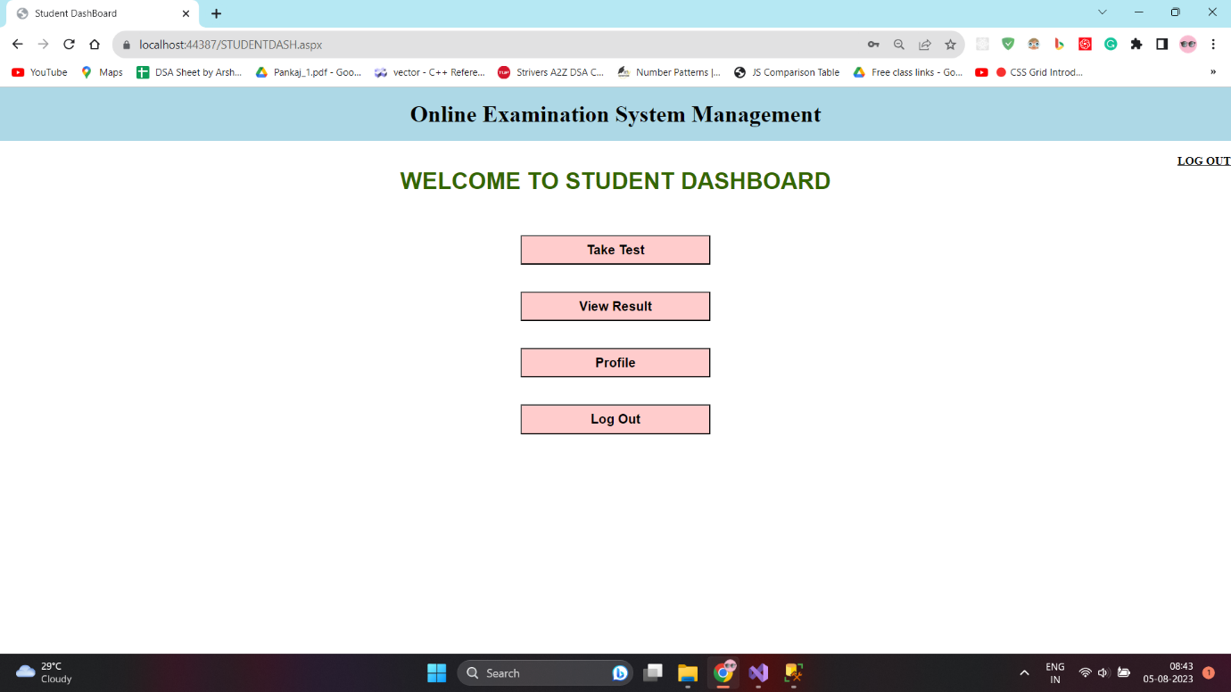

**Fig – Student Dashboard Page**

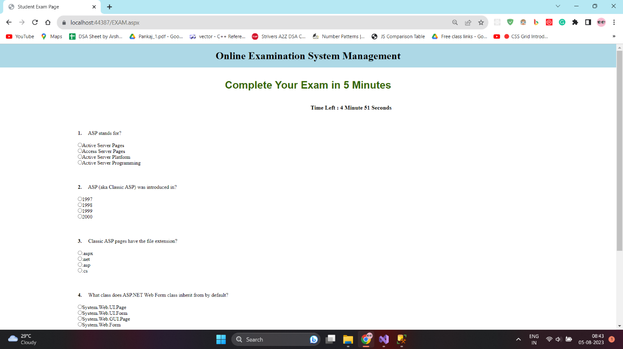

**Fig – Exam Page in Student Section**

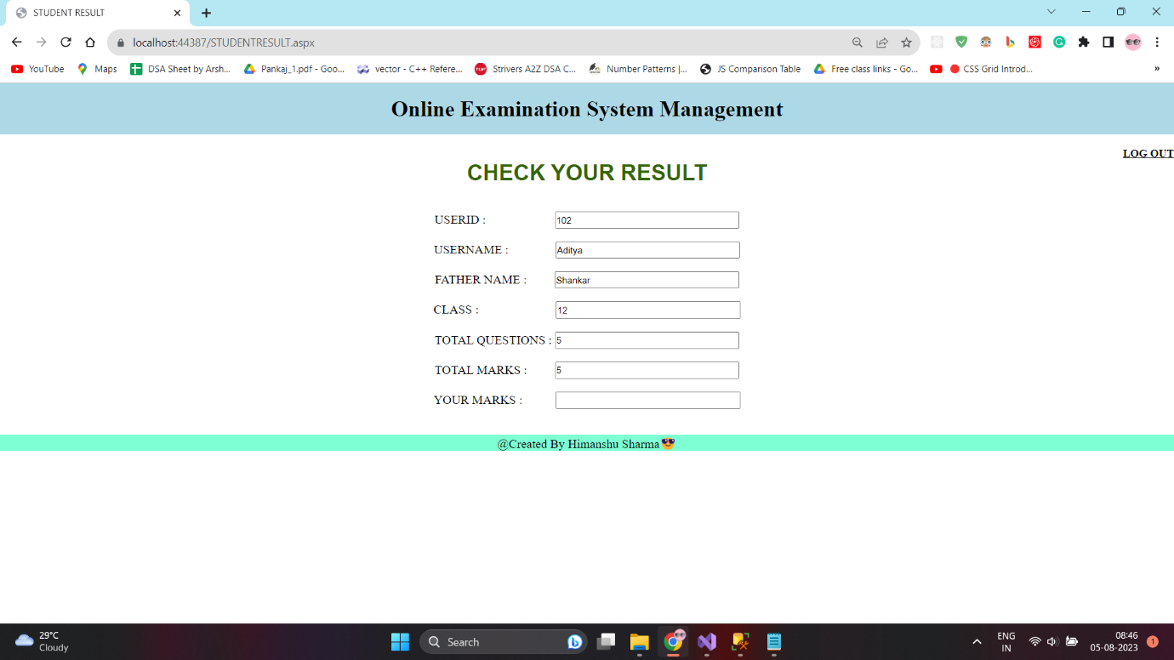

**Fig – Result Section in Student Dashboard**

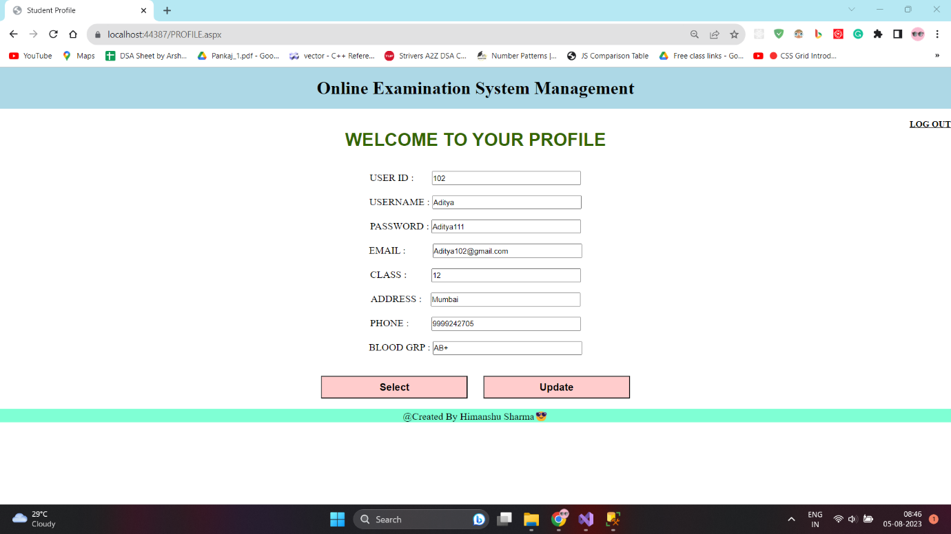

**Fig – Profile Page in Student Section**

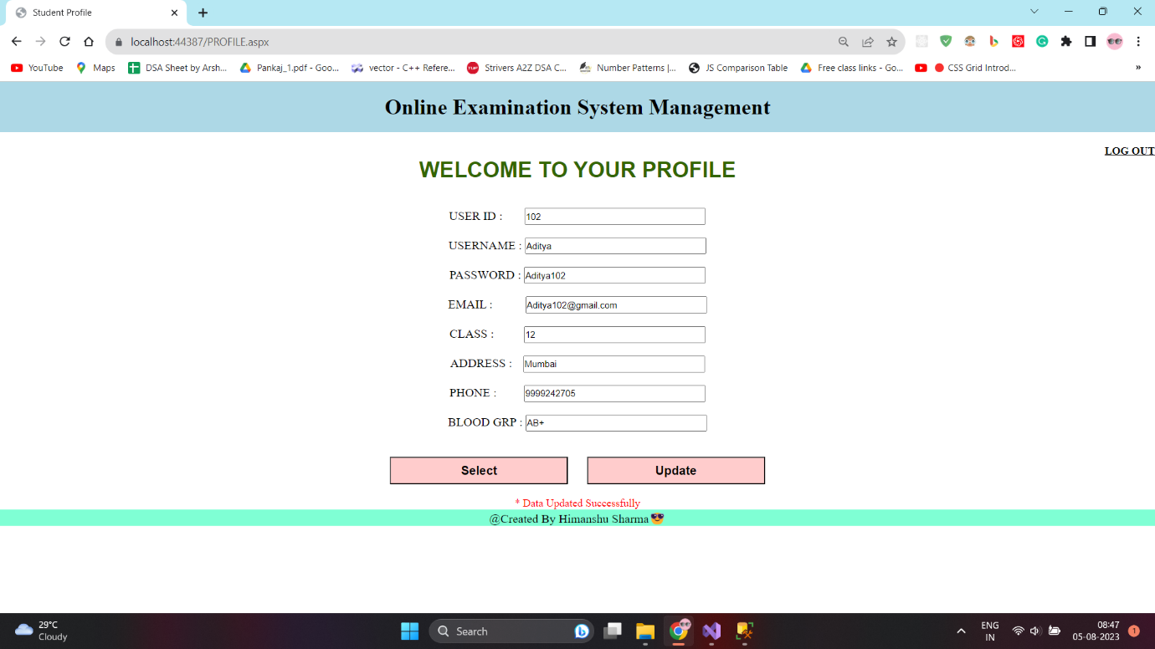

**Fig – Profile Updated using Update Button in profile Page (check label in image)**